Tobacco-Free Recovery

Provider Toolkit

Tools and resources to support health systems change for tobacco treatment



Dear Recovery Residence,

Tobacco and nicotine use is one of the leading causes of premature, preventable death among adults in the United States, and the behavioral health population (mental health and substance use) smokes at a rate that is **2-3 times that of the general population**. As a result, individuals with a behavioral health condition are far more likely to die of tobacco-related diseases than from causes related to their mental illness or substance use disorder.

Why is tobacco and nicotine use higher in this population? Individuals with behavioral health conditions have been:

* Victimized by the tobacco industry’s target marketing
* Exposed to various forms of trauma, increasing the risk of developing addictions
* Suffered from delays in accessing care and less access to quality care
* Subjected to stigma and provider bias

In short, people that have experienced trauma use tobacco as a coping mechanism. Tobacco and nicotine dependency is not a question of “What’s wrong with you,” but rather “What’s happened to you?”

Addressing tobacco and nicotine use is central to achieving health equity, as prevalence is highest among:

* Those with behavioral health conditions (both mental illness and substance use)
* American Indian and Alaskan Native populations,
* Individuals identifying as multiracial
* Individuals identifying as LGBTQ+
* Justice-involved individuals

**Treating an individual’s tobacco use disorder can also improve treatment outcomes for the client’s behavioral health disorders and concurrent tobacco treatment can increase the likelihood of long-term sobriety of all substances by 25%.** Simply put, being tobacco and nicotine free helps residents stay sober and achieve recovery!

Tobacco and nicotine product use causes a number of chronic health issues, including heart disease, lung disease and many kinds of cancers. The single most important thing a tobacco user can do to improve their health is to quit. Evidence-based tobacco treatment intervention in conjunction with tobacco-free policies are important components of creating an environment that is conducive to recovery.





**How to use this document?**

The purpose of this toolkit is to provide guidance for recovery residences adopting tobacco-free policies and implementing tobacco treatment services as part of treatment plans. This toolkit serves as a resource and guide for recovery residence agencies adopting a tobacco-free wellness policy for their facilities and campuses. It provides information on tobacco use among the behavioral health population, as well as a step-by-step guide to becoming a tobacco-free facility and treating tobacco use using evidence-based practices.

**THIS TOOLKIT PROVIDES**

* General information on tobacco addiction and how to provide tobacco treatment services
* How tobacco impacts the behavioral health population
* Step-by-step guidance on how to prepare for and implement a tobacco-free policy in your facility
* Model tobacco-free policies and signage examples
* Trauma-informed care and tobacco resources
* Many resources and references

*This toolkit was developed in collaboration with the Indiana Department of Health Tobacco Prevention and Cessation Commission and Rethink Tobacco Indiana*

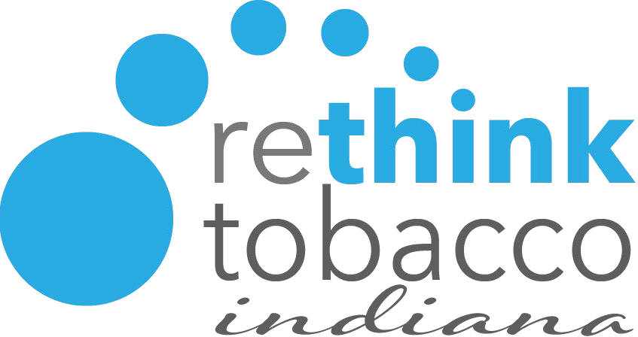 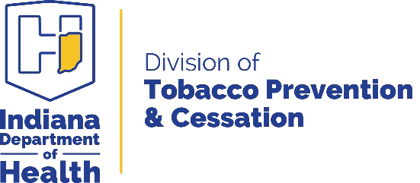



**Table of Contents**

|  |  |
| --- | --- |
| **Part 1: Setting the Stage** | **Pg 5** |
| **Part 2: Taking Your Residence Tobacco-Free** | **Pg 7** |
| **Part 3: Integrating Tobacco Treatment** | **Pg 1**0 |
| **Part 4: Additional Resources** | **Pg 19** |





# PART 1: Setting the Stage

Tobacco use remains one of the leading causes of death among Americans. Tobacco use causes a number of devastating and debilitating diseases, including but not limited to stroke, emphysema and other lung diseases, heart disease and many kinds of cancers.

The single most important thing those that use tobacco can do to improve their health is to quit smoking or using other forms of tobacco and nicotine. Treating tobacco use disorder is an integral part of a larger strategy to promote wellness among the behavioral health population. Whether your facility is a shelter, a residential recovery home, an outpatient clubhouse, community center or clinic, the guidance contained in this document will assist your organization with planning, rolling out and sustaining tobacco-free policies.

**WHY FOCUS ON THOSE WITH BEHAVIORAL HEALTH CONDITIONS (PEOPLE WITH MENTAL ILLNESS(ES) AND/OR SUBSTANCE USE DISORDERS)?**

* Tobacco Use Disorder is a DSM-V Substance Use Disorder and is the most prevalent Substance Use Disorder
* Tobacco dependence treatment, during addictions treatment, is associated with a 25% increased likelihood of long-term abstinence from alcohol and substance use

Despite measures that have greatly reduced smoking in the general population – smoke-free air laws, high cigarette taxes, and effective media campaigns – this population continues to smoke at higher rates, putting them at increased risk of tobacco-related disease and death.

The [Substance Abuse and Mental Health Services Administration (SAMHSA)](https://store.samhsa.gov/sites/default/files/sma16-4953.pdf) outlines 8 dimensions of wellness:

1. Emotional—Coping effectively with life and creating satisfying relationships
2. Environmental—Good health by occupying pleasant, stimulating environments that support well-being
3. Financial—Satisfaction with current and future financial situations
4. Intellectual—Recognizing creative abilities and finding ways to expand knowledge and skills
5. Occupational—Personal satisfaction and enrichment from one’s work
6. Physical—Recognizing the need for physical activity, healthy foods, and sleep
7. Social—Developing a sense of connection, belonging, and a well-developed support system
8. Spiritual—Expanding a sense of purpose and meaning in life



*Creating a tobacco-free environment and supporting cessation are crucial for both the Environmental and Physical aspects of wellness.*



**U.S. Annual Adult Deaths from Smoking**

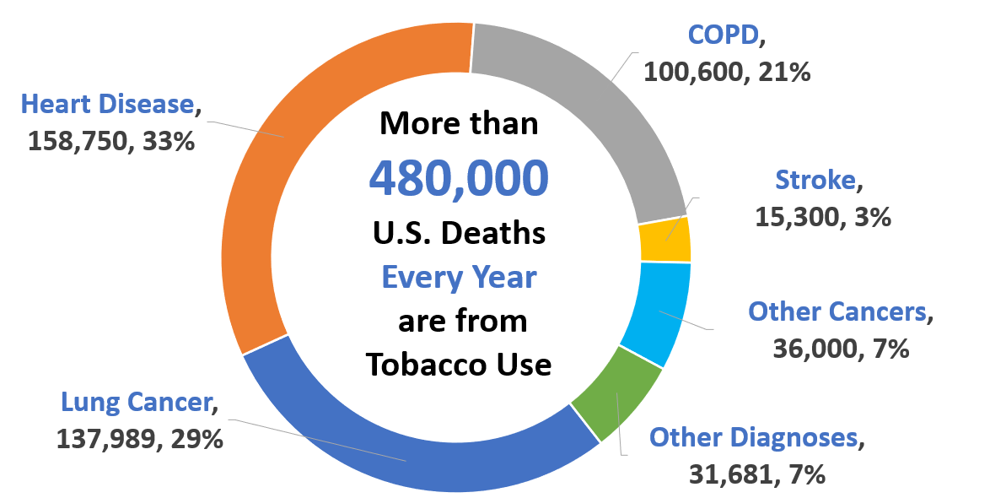

***Nearly 50% of annual deaths occur among consumer with behavioral health conditions.***

Source: CDC. Tobacco-Related Mortality. <https://www.cdc.gov/tobacco/data_statistics/fact_sheets/health_effects/tobacco_related_mortality/index.htm>. Atlanta: U.S. Department of Health and Human Services, Centers for Disease Control and Prevention, National Center for Chronic Disease Prevention and Health Promotion, Office on Smoking and Health

**Current Tobacco Use Trends**

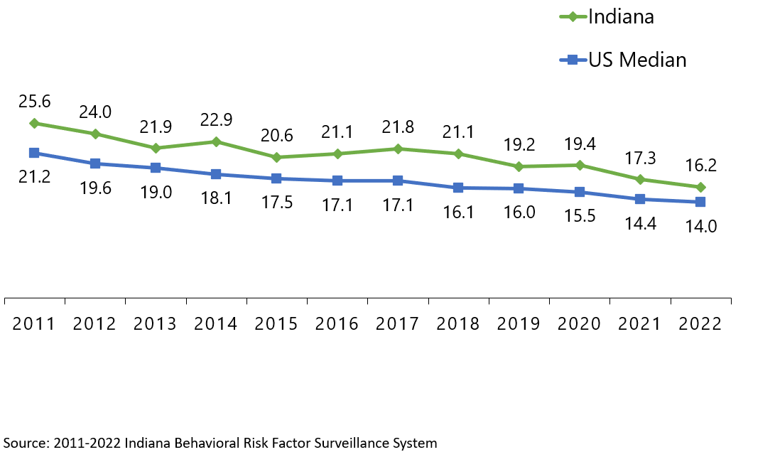



***Indiana’s smoking rate continues to be higher than the US median rate.***



# PART 2: Taking Your Residence Tobacco Free

Health Systems Change: Tobacco-Free Grounds

*Developing and implementing a comprehensive tobacco-free grounds policy*

In 2014, the U.S. Surgeon General concluded that smokefree laws in workplaces and communities help smokers quit and reduce tobacco use. In addition, smokefree workplaces and communities make youth and young adults less likely to start smoking due to a number of factors, including lower visibility of people who use tobacco products, fewer opportunities to use alone or with others, and reduced social acceptability for smoking.

**THE IMPORTANCE OF SMOKE-FREE ENVIRONMENTS**

To assist people with behavioral health conditions in living healthy, meaningful lives, healthcare and social services agencies need to promote behaviors that lead to improved health and overall wellness. Creating a tobacco-free environment is one of the primary ways that a community healthcare agency can create a safer and healthier environment for residents, staff, and visitors. It is an integral part of promoting and supporting wellness for both residents and staff at your facility.

Tobacco free grounds policies can motivate and help tobacco users to quit and prevent initiation of tobacco use. Studies have shown that the implementation of tobacco free grounds policies can increase treatment success rates and reduce smoking prevalence among employees.

* [Smokefree Policies Reduce Smoking](https://www.cdc.gov/tobacco/secondhand-smoke/protection/reduce-smoking.htm)
* [Why Adopt A Commercial Tobacco-Free Grounds Policy as Your “New Normal”](http://action.lung.org/site/DocServer/Why_Adopt_Commercial_TF_Grounds.pdf)
* [Best Practices – Quit Now Indiana](https://www.quitnowindiana.com/best-practices)

***The following strategies should be addressed for developing and implementing a tobacco-free grounds policy:***

## Identify staff or assemble a tobacco-free taskforce/work group responsible for developing and implementing the tobacco-free grounds policy.

***1***

Work group members will provide key input and support on the development, implementation, and sustainability of the tobacco-free policy and procedures. This committee should include a diverse group of individuals ranging from leadership and administrators to staff at all levels of the organization. There might be an existing committee such as a wellness committee that could add this project to their agenda.







|  |  |
| --- | --- |
| ***Click here for* TOBACCO-FREE ENVIRONMENT TOOLKITS** | * [Tobacco-Free Grounds Policy – Model template](https://rethinktobaccoindiana.org/wp-content/uploads/2024/03/sample-tf-grounds-model-policy.docx) |

Did you know that [Rethink Tobacco Indiana](https://rethinktobaccoindiana.org/) offers free assistance, education, and resources?

If your organization is interested in additional fact sheets, journals, and tools – [please follow this link!](https://rethinktobaccoindiana.org/fact-sheets/)





## Place indoor and outdoor tobacco and e-cigarette free signage throughout the clinic/center and grounds.

***2***

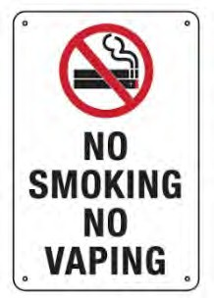

Residents, employees, visitors, and others will need to be informed both directly and indirectly about your new tobacco-free policy. Start by assessing your organization’s needs, including signage. Do you currently have tobacco-free signage? Will your signage need to be updated? These may include tobacco-free signs at all building entrances and around other key areas such as where tobacco use on the property is typically observed.

|  |
| --- |
| ***Click here for* TOBACCO-FREE SIGNAGE TEMPLATES** |

## Build capacity for the targeted clinic/center/residency to provide education to staff and residents on the benefits of tobacco-free policies.

***3***

Organizations should provide education to all staff and residents early and regularly on the new tobacco-free policy and address misinformation and misconceptions about tobacco and tobacco use. Staff should be provided opportunities to learn more about the benefits of tobacco-free policies and their role in helping residents to become motivated to quit. Remember to consider how you will educate new staff members and retrain existing staff.



Add training on the benefits of tobacco-free ground policies to your organization’s electronic learning

management system, incorporate as part of new hire orientation, or add as part of annual competency or team meetings.



|  |  |
| --- | --- |
| Internet  ***Click here for* TOBACCO-RELATED TRAINING RESOURCES** | **Recovery Housing Rules**  Residents have made a choice to live in an environment that is alcohol and drug-free. House Rules are provided to help the facility run smoothly, and to promote a cooperative and supportive environment. These should be updated to reflect a policy of absolutely no tobacco and nicotine use by any resident, staff or visitor on the premises. |

Coordinate messages and activities within the clinic/center to support a tobacco-free environment.

***4***

Successful implementation of a tobacco-free policy relies on clear communication from the early stages of policy development to the policy rollout. Inform staff and residents of the tobacco-free policy timeline as early as possible. Tobacco users will need time to get used to the idea of a tobacco-free campus, and communication and support will help in alleviating anxieties.

**Communicate your plan to transition to a tobacco-free environment:**

* Inform employees and residents as early as possible, offering a chance to receive input
* Provide the rationale behind the decision to implement a tobacco-free policy
* Share goals for policy outcomes, expectations for employees and residents, the implementation process and timeline, and guidelines by which the new policy will be enforced
* Promote support that is available for people who use tobacco

|  |  |
| --- | --- |
| ***Click here for* COMMUNICATION AND TIMELINE RESOURCES** | * [6-Month Policy Development Timeline](https://a29056ea-3253-464f-8cb7-12daec07c7af.filesusr.com/ugd/4340b9_aacd4e19e46649ab80877c05650340d2.xlsx?dn=Tobacco%20free%20timeline%20-%20substance%20use%20treatment%20centers.xlsx) * [Sample tobacco-free policy timeline](http://www.rethinktobaccoindiana.org/wp-content/uploads/2020/08/tf-policy-timeline.pdf) |

## Launch the new policy!

***5***

Consider hosting a kick-off event on the date your new tobacco-free policy is effective. Celebrate and share your organization's efforts and commitment to health and wellness around your community.

Successfully implementing a tobacco-free policy is a huge feat to be proud of -be sure to monitor the policy and respond to any challenges that occur. Consider sharing a copy of your final policy with [Indiana Tobacco Prevention and Cessation](https://www.in.gov/isdh/tpc/2333.htm) as a way to highlight and recognize your organization.



|  |
| --- |
| ***Click here for* TOBACCO-FREE POLICY EXAMPLES AND ADDITIONAL RESOURCES** |



# PART 3: Integrating Tobacco Treatment

Treating Tobacco Use and Dependence

Integrating tobacco dependence treatment

*The following strategies should be addressed for integrating tobacco treatment services:*

**QUITTING TOBACCO IS A CHALLENGE, BUT IT CAN BE DONE**

Considering that tobacco addiction is a chronic, relapsing disease, it is important that residents feel empowered to reduce consumption and/or quit again should there be a set-back. They are more likely to do so when they consider their caregivers as true partners in their recovery from tobacco. Quitting tobacco use and nicotine is challenging, so it is important that residents realize it will likely take multiple quit attempts until they stop for good.

People who quit often start using tobacco again because of stress, cravings, weight gain, and being around others using tobacco products. Residents should not be discouraged by relapse – they can try to quit again and should be encouraged to do so with positive messages that highlight the benefits of quitting (health, money savings, healthy environment for family, improved overall treatment outcomes, etc.) and treat each quit attempt as a learning experience. Stay mindful of how difficult it is to stop; use this knowledge to maintain a compassionate perspective.

**Contrary to popular beliefs**, persons with behavioral health conditions want to quit using tobacco, want information on tobacco treatment services and resources, and most importantly, can successfully quit using tobacco. Studies have found that addicts are interested in quitting tobacco use and nicotine at the time they started treatment for their other addictions. However, residents with other substance use, psychiatric disorders, and strong nicotine dependence are less likely to succeed in a quit attempt without evidence-based treatment interventions.

# Implement a protocol that ensures every person who uses tobacco is identified and offered evidence-based treatment (e.g. pharmacotherapy and counseling). This may also include Quit Now Indiana's Quit Services, and includes documentation of tobacco use and treatment.

***1***

Systems change for tobacco treatment involves strategies implemented at the organizational/ system-level that supports addressing tobacco use consistently and effectively by integrating comprehensive tobacco dependence treatment into routine care. Ask, Advise, Refer (AAR) is the CDC’s evidence-based brief intervention model. The AAR model is commonly used by organizations to make a referral to community resources such as to Quit Now Indiana's Quit Services. When time or logistics do not allow for comprehensive tobacco treatment counseling, staff are encouraged to apply the AAR model as even brief interventions have been shown to be effective and can be achieved in less than five minutes.

# Develop, organize, and implement a training plan for staff to use the AAR best practice model. In addition, training should review the Quit Now Indiana Quit Services suite and the Quit Now Indiana website.

***1A***

***Ask Advise***

**Your organization should ensure that all residents are asked about their tobacco use at every visit (or in the recovery residence this should happen frequently)** and that this information is documented in the EHR. Assessments should capture all forms of tobacco use as well as amount and previous quit attempts.

**Residents who use tobacco should be strongly advised to quit or at least advised to consider quitting.** Advice to quit should be provided in a non-judgmental tone and personalized whenever possible. Try to link the patient’s tobacco use to current mental and physical health or illness, recovery from other substances, impact on children and others in the household, etc.

**Refer your residents to internal tobacco treatment specialists and/or to Quit Now Indiana's Quit Services.** For those willing to quit tobacco within the next 60 days, refer to internal tobacco treatment specialists/addictions counselor, peer recovery specialists or other clinician, and/or to Quit Now Indiana*1-800-QUIT-NOW.* Share other community-based resources for tobacco treatment as needed.

For residents who are not ready to quit, strongly encourage quitting by using personalized motivational messages. Let them know you are there to help them when they are ready, and you can connect them to appropriate resources in the future.

***Refer***

|  |  |
| --- | --- |
| ***Click here for***  ***ASK-ADVISE-REFER RESOURCES*** | * [Ask, Advise, Refer to Quit, Don’t Switch Brief Intervention Training](https://quitdontswitchtraining.lung.org/watch-webinar/) [by the American Lung Association (webinar)](https://quitdontswitchtraining.lung.org/watch-webinar/) |

**A few ideas to get started:**

* Have candid discussions with staff about potential barriers to making referrals and develop potential solutions to mitigate barriers
* Create protocols to incorporate AAR practices at crucial intersections throughout care
* **When working with your residents, consider posing the question:**
* ***If you woke up tomorrow and were not dependent on tobacco, how would your life look?***



Promoting consistent screening for tobacco use among all residents at your organization, requires training and motivating all employees to become involved in the new screening and treatment process. Along with training of the AAR model, employees should be aware of organizational and leadership expectations related to this new process. Consider adopting a tobacco use screening protocol and track clinician, clinic/hospital, staff, and system-level performance to provide feedback to staff and decision-makers and track quality improvement measures – based on your census of residents. Regular communication about how the tobacco treatment process is working is essential for organizational and system improvement.



**Define your organization’s goals for implementing the AAR model.** When determining these goals, think about how you will measure progress toward achieving these goals and evaluate success.

Quit Now Indiana offers a **QNI Champion Provider** program. Once your organization enrolls as a

preferred provider, you will receive several resources to support residents, including status reports

on referred residents for HIPAA-compliant entities.

|  |  |
| --- | --- |
| ***Click here for***  **CLINICIAN AND SYSTEM-LEVEL FEEDBACK RESOURCES** | * [Quit Now Indiana Champion](https://www.quitnowindiana.com/champion-medical-provider) Enrollment * [QNI Provider Materials Order Form](https://www.quitnowindiana.com/educational-materials) |

**Provision of Cessation Medications**

Residencies should offer or facilitate access to nicotine replacement therapy (NRT) or other FDA-approved cessation medications and behavioral counseling to clients and staff members who require assistance refraining from tobacco while onsite.

This assistance should begin as early as possible before the tobacco-free policy goes into effect and last at least 3 months post implementation, if not longer. Your facility’s Human Resources department should communicate to staff about cessation medication benefits offered by their health insurance plans. TIP: Using terms that are more familiar to behavioral health clinicians can help encourage tobacco dependence treatment. NRT is similar to MAT (medication assisted treatment).

*For additional information on Nicotine Replacement Therapies and available resources, please contact Renee Gholson, IDOH Tobacco Prevention and Cessation Training and Engagement Manager, at* [*pgholson@health.in.gov*](mailto:pgholson@health.in.gov)*.*

*For additional information on pharmacotherapies/medications and their use, please contact Gage VanDine, Rethink Tobacco Indiana Community Outreach Manager, at* [*gvandine@iu.edu*](mailto:gvandine@iu.edu)*.*

Ongoing evaluations of the new tobacco screening and treatment protocol (AAR model) should be conducted to achieve effective patient outcomes and improve processes. Consider the below measures to track and report as part of your organization’s new AAR model for tobacco treatment:

* Percentage of identified tobacco users in patient population
* Percentage of residents provided brief counseling and advice to quit
* Percentage of residents using tobacco treatment medications (OTC NRT as well as prescriptions)
* Monthly fax or online referrals to QNI Quit Services and referrals to in-house tobacco treatment specialists
* Percentage of residents quitting success rates at one, three, six, and 12 months, etc.

To help your organization develop “SMARTIE” goals, review the current data you have for the metrics you select. This data will serve as your baseline as you develop SMARTIE, but challenging goals.

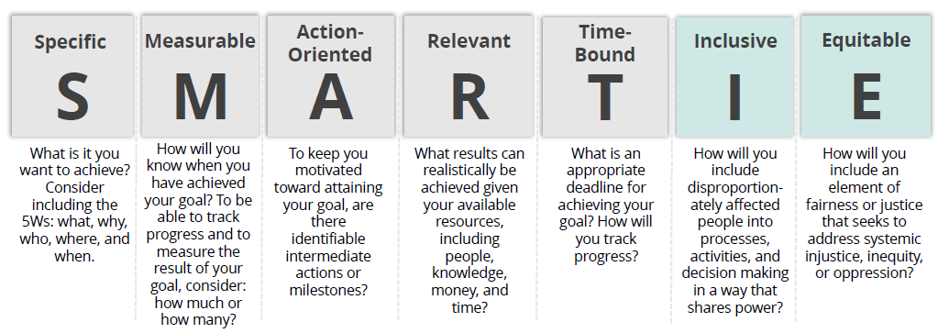





**Several organizations recommend quality improvement for tobacco treatment services and new policies and regulatory forces are driving the need to prioritize tobacco treatment interventions.**

Below are a few examples:

* The Indiana Division of Mental Health and Addiction (DMHA)
* The Quality Payment Program
* The Joint Commission
* The Inpatient Prospective Payment System
* The Patient Protection and Affordable Care Act (ACA)
* The National Quality Forum

|  |  |
| --- | --- |
| ***Click here for* QUALITY IMPROVEMENT RESOURCES** | * [Clinical Decision Support-enabled Quality Improvement Worksheet](http://hiteqcenter.org/Portals/0/pdf/HITEQ%20HIT%20QI%20Guide%20CDS%20QI%20Worksheet_Essential.docx) |



***Tobacco Treatment Interventions***

***1B***

### One-on-one individual counseling



*Can be delivered in-person, by phone, or virtually*

### Group counseling

*Consider integrating into existing group treatments to maximize participation*

### QNI Quit Services



*Offers free and confidential telephone counseling support*

### Text-based programs

*Free text messaging programs like* [*SmokeFreeTXT*](https://smokefree.gov/tools-tips/text-programs/quit-for-good/smokefreetxt?s_cid=OSH_tips_D9402) *can add supplemental support*



Before implementing a system change for tobacco treatment you should **evaluate the current state of your organization by using the** [**Performance Partnership Model**.](https://smokingcessationleadership.ucsf.edu/sites/smokingcessationleadership.ucsf.edu/files/Documents/Publications/ppm_mm_cr_nov_2011.pdf) This evaluation will enable you to easily identify tobacco treatment supports within your organization as well as areas for improvement. Which staff would be most appropriate to deliver tobacco treatment interventions? What resources will you need to start a new tobacco treatment group class? What community supports are available to your residents? After assessing your organization, you can then brainstorm small changes to make to integrate evidence-based tobacco treatment services.

## The Performance Partnership Model



1. Where are we now? (baseline)
2. Where do we want to be? (target)
3. How will we get there? (multiple strategies)
4. How will we know we are getting there? (measures)



It’s a good idea to form a committee or workgroup responsible for developing and implementing your goals and strategies. This committee should include a diverse group of individuals ranging from leadership and administrators to staff at all levels of the organization.

|  |  |
| --- | --- |
| ***Click here for* TOBACCO TREATMENT &**  **SYSTEMS CHANGE TOOLKITS** | **When working with your residents, consider posing the question:**  *If you woke up tomorrow and were not dependent on tobacco, how would your life look?* |



# Provide education, resources, and feedback to promote interventions with residents who use tobacco.

***2***

On at least an annual basis and during onboarding, offer training/technical assistance for staff on evidence-based tobacco dependence treatments, current protocols and other available resources, and provide continuing education (CE) credits and/or other



**Suggested training topics:**

* Link between mental illnesses, substance use, and tobacco dependence
* Screening and assessment tools
* Counseling strategies
* Motivational interviewing
* Evidence-based pharmacotherapy
* Workflow training
* Strategies to work with priority populations
* Tobacco Treatment Specialist training
* Community referrals and resources

incentives for participation, when applicable.

**A Tobacco Treatment Specialist . . .**

Is a professional who possesses the skills, knowledge and training to provide effective, evidence-based interventions for tobacco dependence across a range of intensities. A TTS may engage not only in providing treatment, but also in educating others (e.g. clinicians, administrators, non-tobacco users, etc.) about tobacco dependence treatments. [Click here](https://ctttp.org/accredited-programs/) to view a list of accredited training programs by the CTTTP. Additionally, [Rethink Tobacco Indiana hosts local TTS trainings](http://www.rethinktobaccoindiana.org/tts-trainings/) utilizing the University of Massachusetts Medical School training curriculum.

Provide and promote resources such as ready access to the Quit Now Indiana (QNI) Tobacco Treatment Services and other community resources, self-help materials, and information about effective tobacco dependence treatment medications.





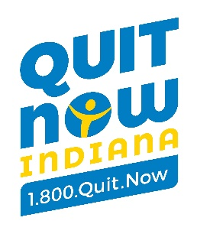

During your organizational assessment, did you consider what resources you have available to promote QNI Services? What resources are available in your community that your residents could access to help with their quit attempts? What type of educational materials and resources do you offer to create a supportive environment for tobacco treatment?

**Quit Now Indiana services include:**

|  |  |
| --- | --- |
| * Nicotine Replacement Therapy | * One-on-one counseling |
| * Online Dashboard access   **Sometimes phone access may be difficult – there are other options available, such as text-based services and online services!** |  |
| * Tailored programming |  |
| * + Youth, pregnancy, and behavioral health |

Quit Now Indiana offers **free promotional materials**, including palm cards, posters, and business cards to transform your clinic into a supportive environment. Select from a variety of tailored materials, including Spanish resources.

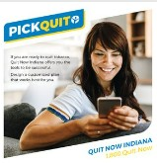

[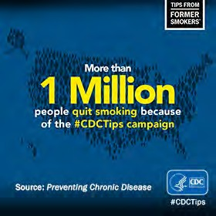](https://www.cdc.gov/tobacco/campaign/tips/about/index.html)[Click here](https://www.quitnowindiana.com/educational-materials) to order QNI Provider Materials

The [CDC’s *Tips from Former Smokers® (Tips®)*](https://www.cdc.gov/tobacco/campaign/tips/resources/index.html)profiles real people living with serious long-term health effects of smoking and secondhand smoke exposure.

The campaign offers materials and posters that you can order, and social media graphics to tailor to specific types of providers and residents.

|  |  |
| --- | --- |
| ***Click here for* TOBACCO DEPENDENCE TREATMENT RESOURCES** | * [Nicotine Withdrawal Symptoms Info Sheet](http://www.rethinktobaccoindiana.org/wp-content/uploads/2020/06/withdrawl-symptoms-information-rti-2020.pdf) * [Cognitive and Behavioral Coping Strategies](http://www.rethinktobaccoindiana.org/wp-content/uploads/2020/06/cognitive-and-behavioral-coping-strategies-rti-2020.pdf) * [Savings Calculator](https://smokefree.gov/quit-smoking/why-you-should-quit/how-much-will-you-save) |



Implement a referral system (fax, online, and/or electronic) to the Quit Now Indiana Quit Services as a tobacco treatment extender.

The 2020 Surgeon General’s Report found that proactive Quitline counseling, when provided alone or in combination with tobacco treatment medications, helps participants end nicotine dependence. Your organization can enroll as a [Quit Now Indiana Champion](https://www.quitnowindiana.com/champion-medical-provider) and receive:

* a welcome email with links to referral options ([fax](https://static1.squarespace.com/static/5a4ec105e9bfdfd7a247017c/t/63924a0bc24b8d417a1b71b4/1683224684774/QNI-Fax-Referral-Form-English.pdf), [online](https://rallycoaching.my.site.com/referral/s/), and [e-referral](mailto:hosimpson@health.in.gov)) and free educational materials,
* monthly Quit Now Indiana e-blasts with QNI promotions and updates,
* and eligibility for [QNI Champion Bronze, Silver, Gold, and Platinum awards](https://static1.squarespace.com/static/5a4ec105e9bfdfd7a247017c/t/65bbe8ea765dfc6e4196f559/1706813675170/QNI_2024_Champion_Awards_Chart.pdf) and recognition.

**Did you know…**

Quit Now Indiana offers a tailored tobacco treatment program for behavioral health consumers! Participants who enroll in the behavioral health program receive enhanced services such as increased number of proactive sessions with a Coach (who has had additional training in mental illness and tobacco) and a 12-week regimen of free combination nicotine replacement therapy.



|  |  |
| --- | --- |
| ***Click here for* REFERRAL RESOURCES** |  |

# Dedicate staff responsible to support tobacco dependence treatment and recommend assessing the delivery of this treatment in staff performance evaluations, if applicable.

***3***

To determine appropriate staff to support tobacco treatment, you need to evaluate how residents advance through each step of your agency, from the time of arrival to departure. Your patient workflow may differ slightly by department or among locations. **Consider the following questions as you evaluate your current patient workflow:**

* + Where do residents go when they arrive?
  + What do residents see and do when they arrive?
  + How is the resident’s tobacco use status being asked?
  + How does staff support tobacco treatment during the visit?
  + How is tobacco counseling and/or other treatment documented?
  + What prompts are in place to alert staff of opportunities to discuss tobacco treatment?
  + What resources are available to residents if they are interested in quitting?



**Leadership**

In addition to the support from agency/clinic leadership, it is important to identify a “**tobacco champion**” who will serve to coordinate and champion the tobacco treatment initiatives. This person must be passionate about assisting residents to improve their quality of life by quitting tobacco. The “tobacco champion” at your site will help to reinforce needed system changes to support evidence-based tobacco treatment efforts.

These may include:

* Assessing patient workflow for tobacco treatment
* Coordinating tobacco treatment trainings (consider having champion trained)
* Ensuring tobacco screening, assessment, and treatment is captured and documented into the EHR and treatment plans
* Answering questions, such as questions about tobacco treatment medications
* Monitoring and evaluating reports to ensure improvement and project success
* Maintaining up-to-date resources, share new research and evidence-based practices, etc.



|  |  |
| --- | --- |
| ***Click here for* TOBACCO WORKFLOW RESOURCES** |  |

# Consider designating a tobacco dependence treatment advocate for selected settings

***4***

Consider the peer support model to promote tobacco treatment and recovery at your organization. Peer specialists can facilitate positive change through goal setting, education, and skills building by sharing their own recovery journeys and modeling healthy decision-making. Additionally, peer specialists can provide support, increase engagement and activation in treatment, increase community engagement, and decrease self-stigma – all of which can be challenges when working with residents who are not yet ready to quit.



***Click here for* TOBACCO TREATMENT ADVOCATE RESOURCES**



**PART 4: Additional Resources**

**Rethink Tobacco Indiana**

<https://rethinktobaccoindiana.org/>

**Quit Now Indiana**

<https://www.quitnowindiana.com/>

**Indiana Tobacco Prevention and Cessation**

<https://www.in.gov/health/tpc/>

**American Cancer Society**

<http://www.cancer.org>

American Cancer Society provides a comprehensive Guide to Quitting Smoking, which reviews medications available and provides tips for successful quit attempts.

**American Lung Association**

<http://www.lungusa.org>

In addition to cessation information and education provided on the website, the American Lung Association hosts Freedom

**Americans for Non-Smokers’ Rights**

<http://www.no-smoke.org>

This website is a great resource for model tobacco-free policy language, and a comprehensive list of smoke-free businesses

**Behavioral Health and Wellness Program, University of Colorado Denver**

<http://www.bhwellness.org>

The Behavioral Health and Wellness Program provides training and technical assistance regarding organizational change, policy implementation, and integrating cessation services into behavioral health treatment. Free reports and literature for implementing tobacco-free policies are available.

**Case studies**

Promising Policies And Practices To Address Tobacco Use By Persons With Mental And Substance Use Disorders

<https://www.cdc.gov/tobacco/disparities/promising-policies-and-practices/pdfs/osh-behavioral-health-promisingpractices-20160709-p.pdf>

**Centers for Disease Control and Prevention**

<http://www.cdc.gov/tobacco>

The Centers for Disease Control and Prevention offers comprehensive smoking cessation materials and links to state and community resources.



**The Center for Tobacco Cessation**

<https://www.nobutts.org/free-training>

The Center for Tobacco Cessation (CTC) is the training and technical arm of the California Smokers’ Helpline. CTC helps organizations throughout California to increase their capacity in tobacco cessation. The Center offers webinars, online courses, toolkits, training and technical assistance.

**Cessation Treatment for the Behavioral Health Population**

The Substance Abuse and Mental Health Services Administration’s website: <https://www.integration.samhsa.gov/health-wellness/wellness-strategies/tobacco-cessation-2>

**National Association of State Mental Health Program Directors**

<http://www.nasmhpd.org>

NASMHPD has developed a series of policy and research reports including a toolkit for “Tobacco-Free Living in Psychiatric Settings.”

**Partnership for Prevention**

<http://www.prevent.org>

Resources are available for establishing smoke-free policies in indoor worksites and public places.

**Public Health Law Center**

<https://www.publichealthlawcenter.org/>

Offers resources on legal and policy issues that health leaders and policymakers can use to control the epidemic of commercial tobacco use.

**Smoking Cessation Leadership Center**

Substance Abuse and Mental Health Services Administration’s (SAMHSA) National Center of Excellence for Tobacco-Free Recovery toll-free 1-877-509-3786

<http://smokingcessationleadership.ucsf.edu>

The Smoking Cessation Leadership Center provides free technical assistance and the latest news and information on tobacco control, as well as links to online webinars and healthcare provider resources for helping residents quit smoking.

**Tobacco Recovery Resource Exchange**

<https://tobaccorecovery.oasas.ny.gov/>

Developed for behavioral health and addiction treatment organizations, the Tobacco Recovery Resource Exchange provides online training, manuals, and toolkits for integrating tobacco treatment and implementing tobacco-free policies.



**Trauma Informed Care Resources**

The following resources aim to provide knowledge to service providers working with individuals who have experiences or have been affected by trauma. Working from a trauma-informed perspective and developing trauma-informed relationships that cultivate safety, trust and compassion is important to treating tobacco and nicotine dependence in recovery residence settings.

* [Trauma Informed Approaches to Tobacco Prevention and Cessation](https://rethinktobaccoindiana.org/wp-content/uploads/2024/01/trauma-informedapproachestotobaccopreventionandcessationbrief-tpc.pdf)
* [Using Trauma-Informed Motivational Interviewing to Support Tobacco Cessation](https://rethinktobaccoindiana.org/wp-content/uploads/2024/01/trauma-informed-mi-to-support-tobacco-cessation_final-9.16.2019.pdf)
* [Connecting the Dots: Addiction, Trauma and Tobacco Use](https://rethinktobaccoindiana.org/wp-content/uploads/2024/01/addiction-trauma-and-tobacco-use_final_2019.06.17.pdf)
* [Fostering Resilience and Recovery: A Change Package for Advancing Trauma-Informed Primary Care](https://rethinktobaccoindiana.org/wp-content/uploads/2024/01/fosteringresiliencechangepackage-ti-rosc-trauma.pdf)
* [Advancing Trauma Informed Care](https://www.chcs.org/project/advancing-trauma-informed-care/)
* [Self-Care: Taking Care of Ourselves So We Can Take Care of Others](https://outreach-partners.org/wp-content/uploads/2017/03/Self-Care-Resource.pdf)

|  |  |
| --- | --- |
| **TOBACCO-FREE ENVIRONMENT TOOLKITS** | * [Key staff to invite to your tobacco-free committ](http://www.rethinktobaccoindiana.org/wp-content/uploads/2020/11/establishing-tobacco-workgroup.pdf)ee * [Tobacco-free Policy Planning Sample Budget](http://www.rethinktobaccoindiana.org/wp-content/uploads/2020/11/tf-policy-sample-budget-worksheet.pdf) |
| **TOBACCO-FREE SIGNAGE TEMPLATES** | * [No Tobacco Use Signs - Printable](http://www.rethinktobaccoindiana.org/wp-content/uploads/2020/10/no-smoking-or-vaping-signs-printable.pdf) * [Tobacco-Free Campus Signage Examples](http://www.rethinktobaccoindiana.org/wp-content/uploads/2020/11/tf-grounds-signage.docx) * [Tobacco Free Signage](https://a29056ea-3253-464f-8cb7-12daec07c7af.filesusr.com/ugd/4340b9_c48d116868734d6b9a2547866f95e225.pdf) |
| Internet  **TOBACCO-RELATED TRAINING RESOURCES** | * [Purdue University College of Pharmacy](https://www.eventreg.purdue.edu/online/USPHSTobaccoCessation.)   Offers free continuing education on variety of tobacco-related topics. Account creation required.   * [Helping Behavioral Health Patients Quit Tobacco Use](https://ctri.wisc.edu/providers/education/tobacco-treatment-training/)   Free CE credits from the University of Wisconsin. Account creation required. |
| **COMMUNICATION AND TIMELINE RESOURCES** | * [Steps and Strategies for Working with Employees Regarding Tobacco-Free Policy](http://www.rethinktobaccoindiana.org/wp-content/uploads/2020/08/tf-grounds-policy-train-employees.pdf) * [Sample tobacco-free policy timeline](http://www.rethinktobaccoindiana.org/wp-content/uploads/2020/08/tf-policy-timeline.pdf) |
| **TOBACCO-FREE POLICY EXAMPLES AND ADDITIONAL RESOURCEs** | * [Tobacco-Free Grounds Policy – Model template](http://www.rethinktobaccoindiana.org/wp-content/uploads/2020/08/cmhc_tobaccofree_grounds_policy_model.docx) * [Implementing Tobacco-Free Policies in Community Behavioral Health](https://www.bhthechange.org/resources/webinar-implementing-tobacco-free-policies-in-community-behavioral-health-organizations/) O[rganizations (archived](https://www.bhthechange.org/resources/webinar-implementing-tobacco-free-policies-in-community-behavioral-health-organizations/) webinar) |
| **ASK-ADVISE-REFER RESOURCES** | * [Tobacco Use Screening EHR Example](https://resources.chronicdisease.org/dir/wp-content/uploads/2020/04/TCCP_tools_best_practices_emr.pdf#page%3D3) * [You can Help Your Patents Quit Tobacco Use - CDC](https://www.cdc.gov/tobacco/campaign/tips/partners/health/materials/You-Can-Help-Your-Patients-Quit-Tobacco-Use-508.pdf) * [Patient-Centered Tobacco Cessation Workflow for Healthcare Clinics](https://resources.chronicdisease.org/dir/wp-content/uploads/2020/04/TCCP_tools_tob_cessation_workflow.pdf#page%3D4) * [Quit Now Indiana’s Tobacco Cessation Guidelines](https://www.in.gov/quitline/files/QL_TobCessGuide_FIN.pdf) * [Counseling your Residents about Tobacco Cessation](http://www.sfhp.org/files/Counseling-Your-Patients-about-Tobacco-Cessation.pdf) * [Smoking and Mental Health - Ask & Act video](https://www.aafp.org/family-physician/patient-care/care-resources/tobacco-and-nicotine/office-champions/behavioral-health-tobacco-cessation/tobacco-nicotine-video.html) * [Treating Tobacco Use and Dependence, Clinical Practice Guideline: 2008 Update – Quick reference guide](https://www.ahrq.gov/sites/default/files/wysiwyg/professionals/clinicians-providers/guidelines-recommendations/tobacco/clinicians/references/quickref/tobaqrg.pdf) * [Ask, Advise, Refer – CDC Pocket Card for Clinicians](https://www.cdc.gov/tobacco/campaign/tips/partners/health/materials/twyd-5a-2a-tobacco-intervention-pocket-card.pdf) |
| **CLINICIAN AND SYSTEM-LEVEL FEEDBACK RESOURCES** | * [Understanding Performance Measures – National Quality](https://resources.chronicdisease.org/dir/wp-content/uploads/2020/04/TCCP_tools_understanding_pms.pdf) Forum * [Protocol for Identifying and Treating Patients Who Use Tobacco](https://millionhearts.hhs.gov/files/Tobacco-Cessation-Protocol.pdf) |
| **QUALITY IMPROVEMENT RESOURCES** | * [Tobacco Cessation Quality Measures](https://resources.chronicdisease.org/dir/wp-content/uploads/2020/04/TCCP_tools_ala_tob_cess_qual_measures.pdf) * [Quality Improvement Essentials Toolkit](http://www.ihi.org/resources/Pages/Tools/Quality-Improvement-Essentials-Toolkit.aspx) |
| **TOBACCO TREATMENT & SYSTEMS CHANGE TOOLKITS** | * [DIMENSIONS: Tobacco Free Toolkit for Healthcare Providers](https://smokingcessationleadership.ucsf.edu/sites/smokingcessationleadership.ucsf.edu/files/Downloads/Toolkits/TF-Toolkit-Supp-Behavioral-Health.pdf) * [Treating Tobacco Dependence Practice Manual: A Systems Change Approach](https://www.aafp.org/dam/AAFP/documents/patient_care/tobacco/practice-manual.pdf) * [Help your Patients Quit Tobacco Use: Implementation Guide for Community Health](https://resources.chronicdisease.org/dir/wp-content/uploads/2020/04/TCCP_tools_implementation_guide_chc.pdf#page%3D46) [Centers – Case Studies](https://resources.chronicdisease.org/dir/wp-content/uploads/2020/04/TCCP_tools_implementation_guide_chc.pdf#page%3D46) |
| **TOBACCO DEPENDENCE TREATMENT RESOURCES** | * [Learning About Healthy Living (Group](https://rwjms.rutgers.edu/images/Departments/Psychiatry/Addiction%20Psychiatry/2012lahl.pdf) curriculum) * [Smoking and Viral Respiratory Infections](http://www.rethinktobaccoindiana.org/wp-content/uploads/2020/05/smoking-and-viral-respiratory-infections-04-24-2020-tpc-factsheet.pdf) * [Factsheets, Journal Articles, & Tools](http://www.rethinktobaccoindiana.org/fact-sheets/) * [Tobacco use fact sheets](https://www.in.gov/health/tpc/evaluation-and-research/fact-sheets/) |
| **REFERRAL RESOURCES** | * [QNI Preferred Provider Enrollment](https://www.quitnowindiana.com/preferred-provider) * [QNI Fax Referral Form](https://static1.squarespace.com/static/5a4ec105e9bfdfd7a247017c/t/5da5e637e5976237a0d73a4f/1571153464091/QL_ClinicFaxReferralForm.pdf) * [QNI Online Referral Portal – User Guide](https://static1.squarespace.com/static/5a4ec105e9bfdfd7a247017c/t/5ada060b8a922ddfc2c0e9ab/1524237837091/QuitNowReferralGuide.pdf) * [SmokeFree.gov](http://www.smokefree.gov/) * [Order 1-800-QUIT-NOW Notepads for Providers](https://wwwn.cdc.gov/OSH_Pub_Catalog/SelectionDetails.aspx?p=V96HIpZOOlO1i7vMG9%2fBJ%2b7ABk2RkbciC%2bCOItOwYVs%3d) |
| **TOBACCO WORKFLOW RESOURCES** | * [Patient Workflow Worksheet](http://www.rethinktobaccoindiana.org/wp-content/uploads/2020/11/patient-workflow-worksheet.pdf) * [Implementation Self-Assessment](https://resources.chronicdisease.org/dir/wp-content/uploads/2020/04/TCCP_tools_ks_tob_guide_behav_health.pdf) * [Tobacco Cessation Protocol](https://millionhearts.hhs.gov/files/Tobacco-Cessation-Protocol.pdf) * [Tobacco Cessation Workflow](https://resources.chronicdisease.org/dir/wp-content/uploads/2020/04/TCCP_tools_tob_cessation_workflow.pdf#page%3D5) * [Referral to Quitline Workflow](https://resources.chronicdisease.org/dir/wp-content/uploads/2020/04/TCCP_tools_quit_connect_health_manual.pdf#page%3D10) * [Workflow for Tobacco Counseling](https://resources.chronicdisease.org/dir/wp-content/uploads/2020/04/TCCP_tools_thsc_toolkit_for_clinics.pdf#page%3D24) |
| **TOBACCO TREATMENT ADVOCATE RESOURCES** | * [Peer Support Program Toolkit](https://www.bhwellness.org/toolkits/Peer-Support-Program-Toolkit.pdf) * [Peer Supports for Tobacco Cessation for Adults with SMI](https://www.ncbi.nlm.nih.gov/pmc/articles/PMC3419592/pdf/nihms384380.pdf) * [Roles for Certified Peer Specialists to Support Peers as they Address](https://d3futrf33lk36a.cloudfront.net/wp-content/uploads/sites/240/2020/09/Certified-Peer-Specialist-Report.pdf) [their Smoking](https://d3futrf33lk36a.cloudfront.net/wp-content/uploads/sites/240/2020/09/Certified-Peer-Specialist-Report.pdf) |